Version 1.1

April 6, 2014

Route Me

Midterm: Hackathon



# Route Me

Route me is an application which can help the client to find his location and the nearby places around him. All the map services are powered by google and four square.

## Architecture Diagram

Architecture shows how the Existing API are used to create the location services and navigation services.



## Class Diagram



## Features Implemented

### Publishing the web application using Microsoft Azure

Implemented the Cloud services:

* Created a cloud account in Azure using Microsoft live ID
* Student logins will be getting 200$ worth azure services free
* Deployed to Android application using visual studios.
* Successfully deployed to cloud

## Screen Shots

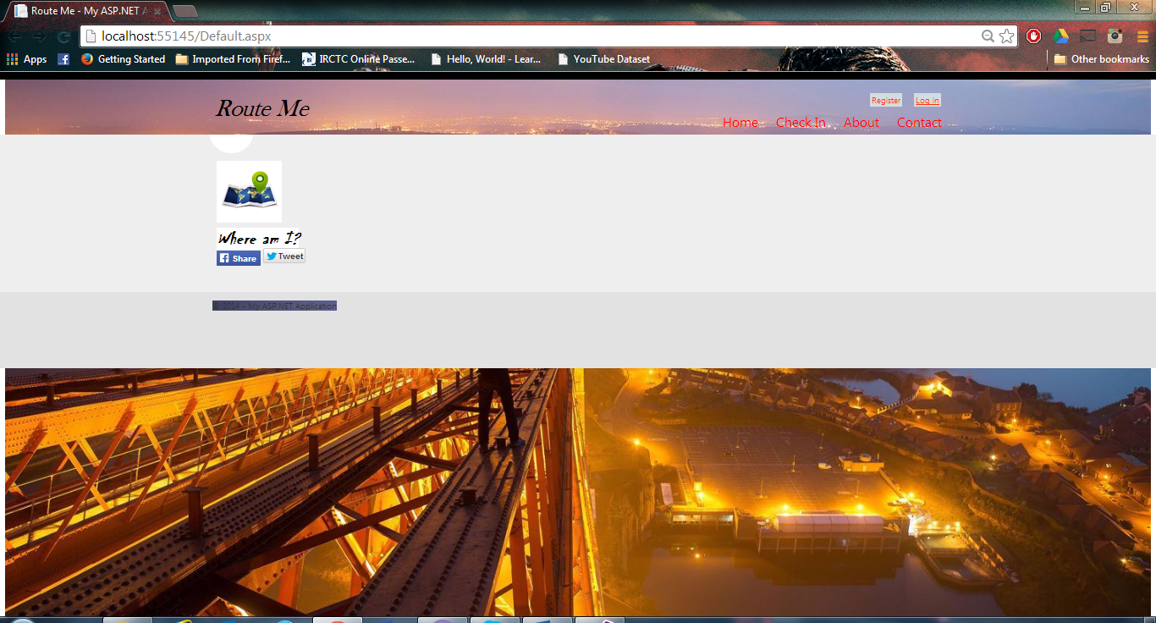

### Facebook API

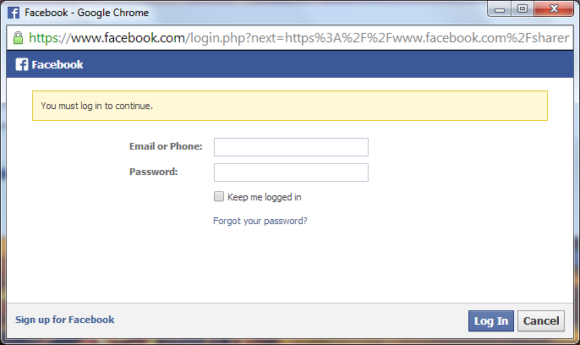

### Twitter API

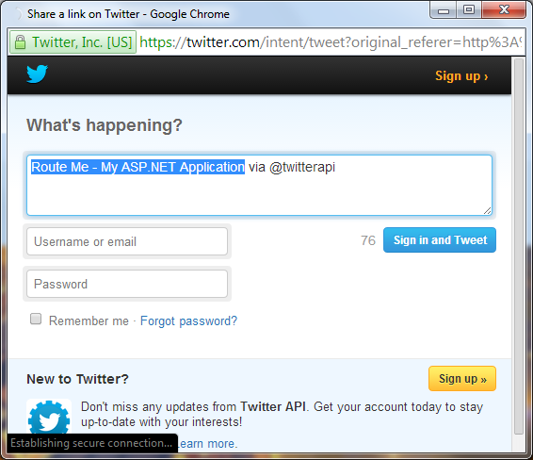

### Geolocation

### 

### Foursquare Check IN places

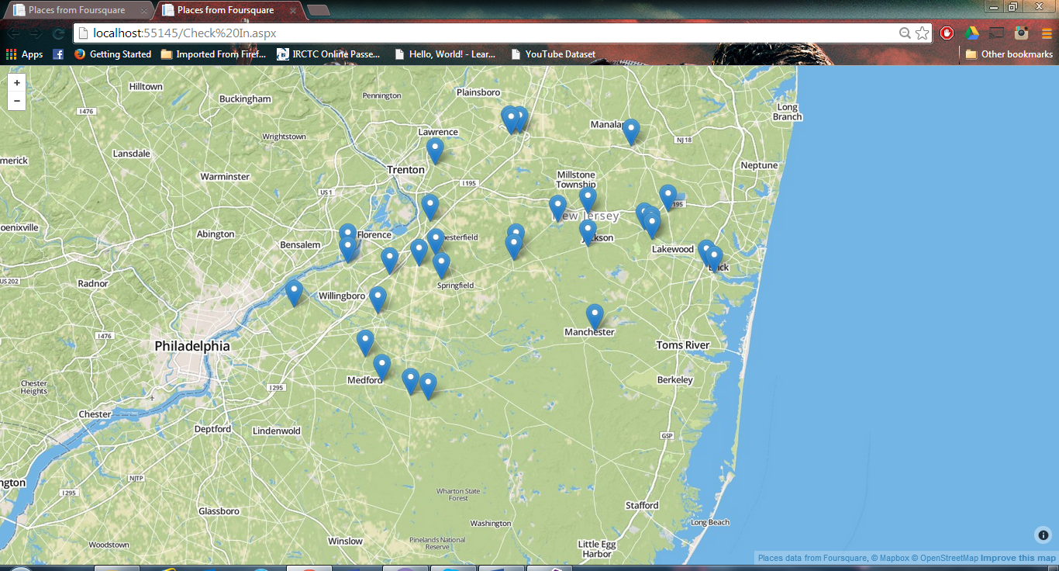

Publishing to Azure

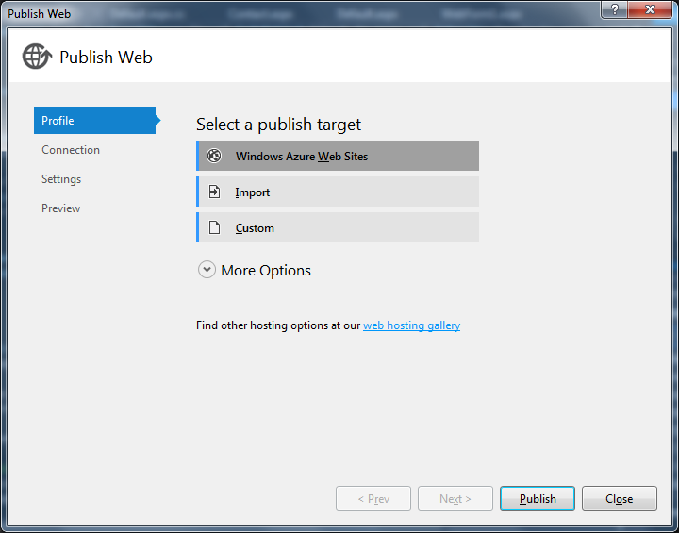

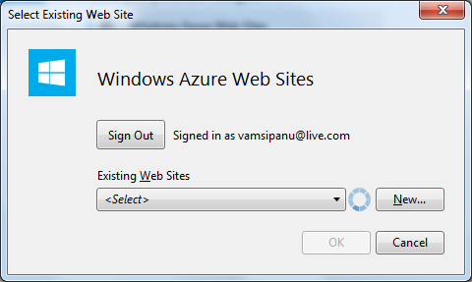

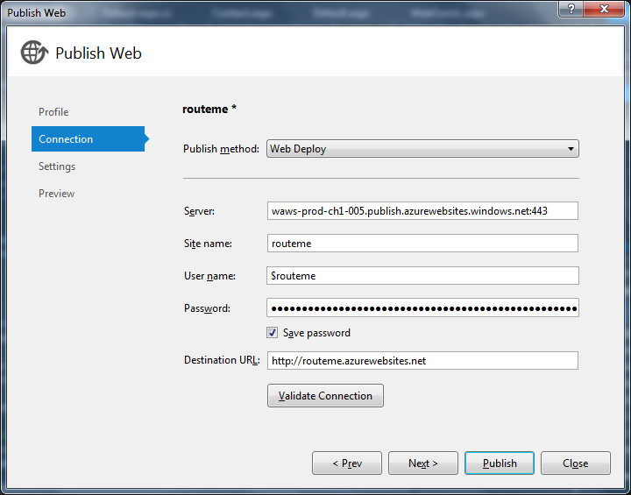

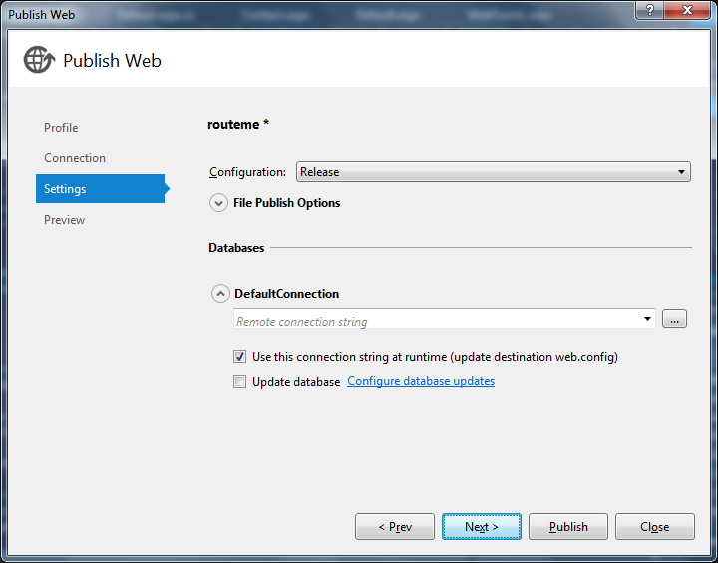

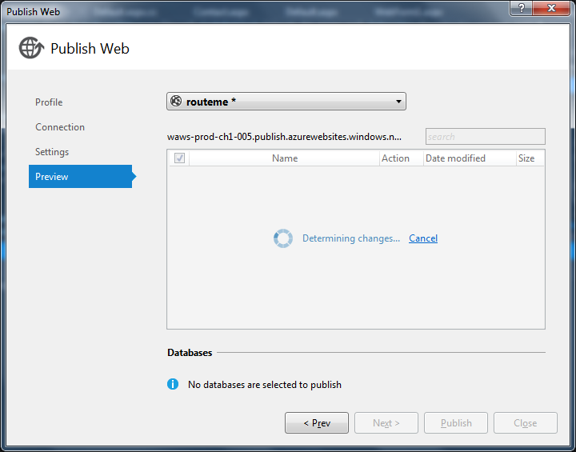

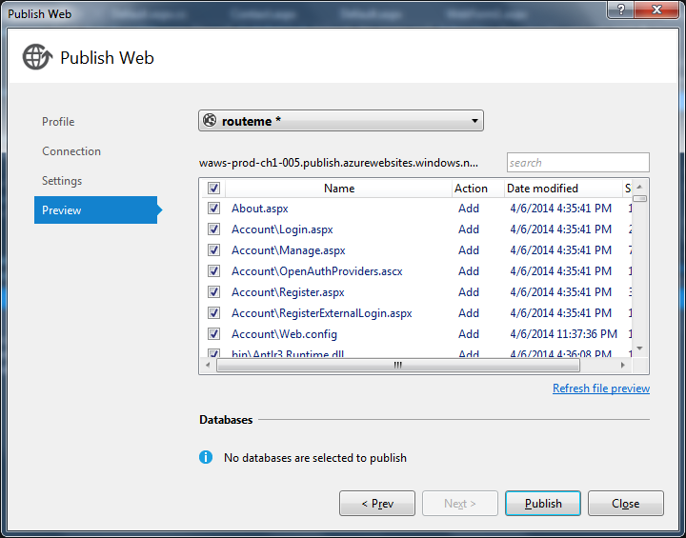

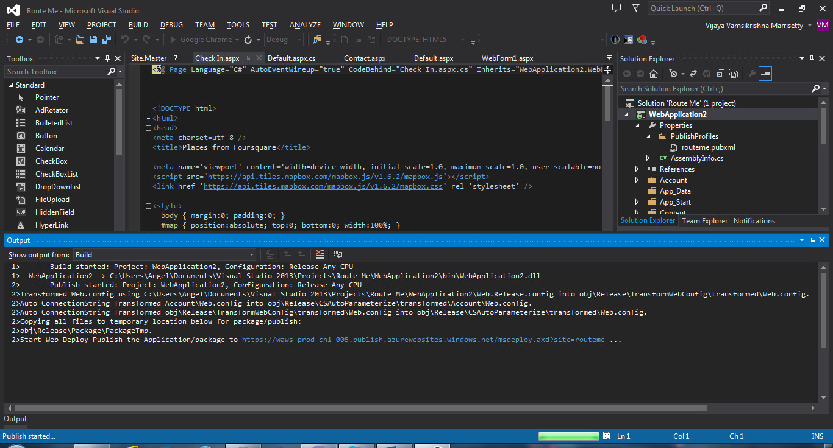

## web site URLS

Azure Cloud URL: <http://routeme.azurewebsites.net/>

Github URL: <https://github.com/vmwz8/ASEmidterm>

## Technical and architectural requirements

User Interface (Web Framework)**:**

* HTML
* CSS
* JavaScript

Web Services:

* Microsoft Visual Studio 2010 ( C#)
* Azure Cloud

UML /Architecture Diagrams**:**

* Microsoft Visio 2013
* Visual Paradigm

## References

* Foursquare website https://foursquare.com/
* Foursquare API https://developer.foursquare.com/start
* Google Earth Vehicle Simulators http://www.gelib.com/simulators.htm
* Text-to-speech http://www.oddcast.com/home/demos/tts/tts_example.php
* Google Developer Site https://developers.google.com/
* Twitter Developer Site https://dev.twitter.com/
* Facebook Developer Site https://developers.facebook.com/

## Technical and architectural requirements

User Interface (Web Framework)**:**

* HTML
* CSS
* JavaScript

Web Services:

* Microsoft Visual Studio 2010 ( C#)
* Azure Cloud

UML /Architecture Diagrams**:**

* Microsoft Visio 2013
* Visual Paradigm